Creating a Rainbow using Graphics

Mini project report submitted in partial fulfilment of the requirements of the degree of

**Second year of Engineering**

by

|  |  |
| --- | --- |
| **Name of student** | **Roll number** |
| Tausif Khan | 12 |
| Parth Bhatt | 06 |
| Naveed Merchant | 17 |

Under the guidance of

**Ms. Shraddha Dabhade**



Department of Computer Engineering

St. John College of Engineering and Management

University of Mumbai

2019-2020

**CERTIFICATE**

This is to certify that the project entitled **“**Creating a Rainbow using Graphics**”** is a Mini Project report of

**“Tausif Khan” (12)**

**“Parth Bhatt” (06)**

**“Naveed Merchant” (17)**

submitted in partial fulfilment of **“Second year of Engineering”** in **“Computer Engineering”** as laid down by University of Mumbai during the academic year 2019-2020.

Ms. Shraddha Dabhade

**Guide**

Dr. Rahul Khokale Dr. G.V. Mulgund

**Head of Department** **Principal**

**CONTENT**

|  |  |  |
| --- | --- | --- |
| **Sr No** | **Content** | **Page No** |
| 1 | Introduction | 1-2 |
| 2 | Implementation | 2-4 |
| 3 | Results | 4-6 |
| 4 | Conclusion | 6-7 |
| 5 | References | 7-8 |

**Introduction:-**

Creating a Rainbow using Graphics

The **graphics**. h header file provides access to a simple **graphics** library that makes it possible to draw lines, rectangles, ovals, arcs, polygons, images, and strings on a graphical window. The second step is initialize the **graphics** drivers on the **computer** using initgraph method of **graphics**. h library.

In Turbo C graphics we use **graphics.h** functions to draw different shapes(like circle, rectangle etc), display text(any message) in different format(different fonts and colors). By using graphics.h we can make programs, animations and also games. These can be useful for beginners.

**Functions Used :**

* **delay(n):** A function from dos.h header file is responsible for holding of the program for a while depending upon given value n.
* **setcolor(n):** A function from graphics.h header file which set the color of pointer(cursor).
* **arc(x,y,a1,a2,r):** A function from graphics.h header file which draw an arc with (x,y) as centre (a2-a1) as angle and r as radius.

## **Implementation:-**

# **Creating a Rainbow using Graphics Programming in C**

Below is the implementation of program.

// A C program to make a rainbow. This program would only

// work in Turbo C compiler in DOS compatible machine

#include<stdio.h>

#include<graphics.h>

#include<dos.h>

// function for making of rainbow

void rainbow()

{

// auto detection

int gdriver = DETECT,gmode;

int x, y, i;

// initialize graphics mode(passed three arguments to

// initgraph function)

// &gdriver is the address of gdriver variable, &gmode is

// the address of gmode and

// "C:\\Turboc3\\BGI" is the directory path where BGI files are stored

initgraph(&gdriver,&gmode,"C:\\Turboc3\\BGI");

x = getmaxx() / 2; //finding centre x-ordinate of screen

y = getmaxy() / 2; //finding centre y-ordinate of screen

for (i=30; i<200; i++)

{

// delay function under dos.h for holding the

// function for some time

delay(100);

// selecting color for making of rainbow

setcolor(i/10);

// making of arc with fixed centre and increasing radius

arc(x, y, 0, 180, i-10);

}

}

// driver program

int main()

{

rainbow();

return 0;

}

**Results:-**

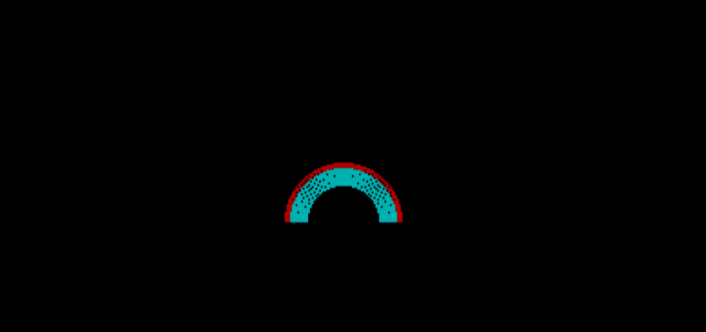

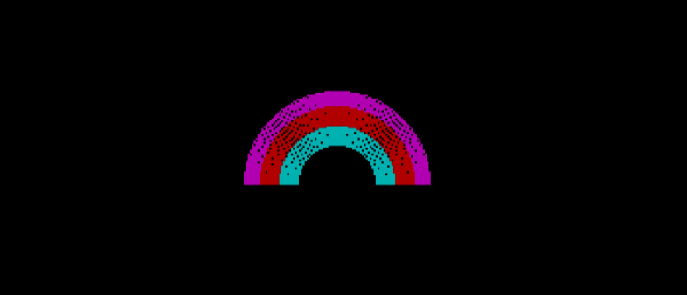

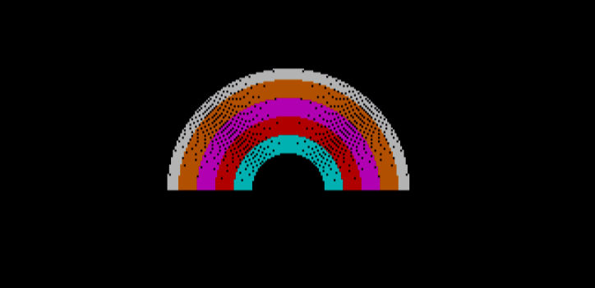

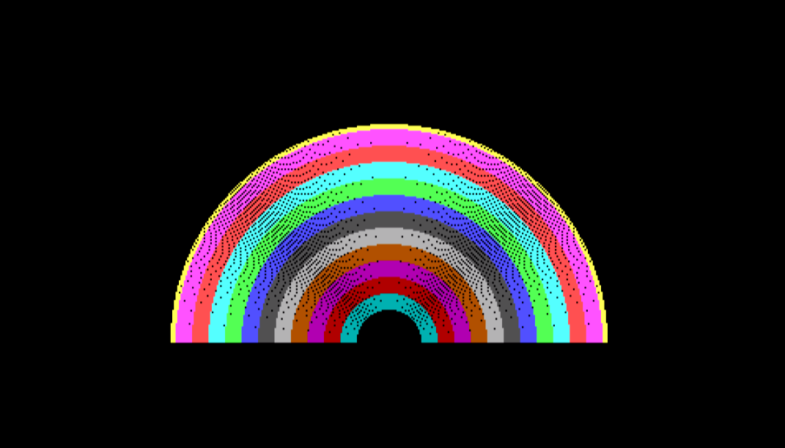

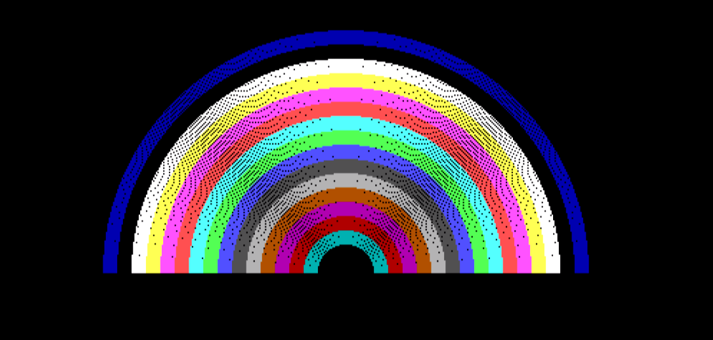

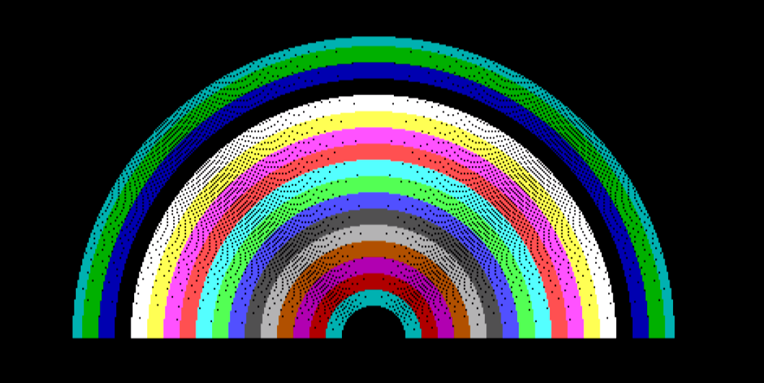

**Conclusion:-**

# Thus in this project we have studied and implemented a simple project Rainbow using graphics and also learn graphics library. And also learn computer graphics concepts and library functions.

**References:-**

1. <https://www.geeksforgeeks.org/creating-rainbow-using-graphics-programming-c/>

2. https://developerinsider.co/download-turbo-c-for-windows-7-8-8-1-and-windows-10-32-64-bit-full-screen/